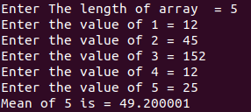
PROBLEM -1 OUTPUT

